1. Jatin: The stoploss will be below the support area.
2. 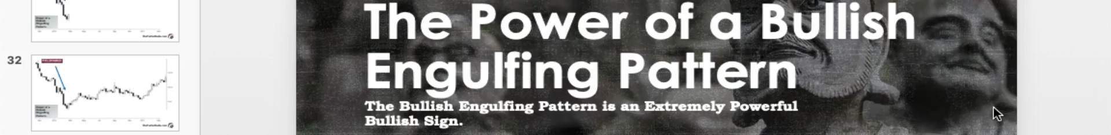
3. The higher the timeframe, the higher is the probability that our trade will work with the pattern.
4. A graph with red text and numbers

   Description automatically generated with medium confidence